Day 9 : 24 Sep 2024

Same existing project spring boot validation using ORM Validator starter and handle global exception

If we want to do spring boot validation we need add validator starter.

Spring cloud and spring micro service

Limitation of Monolithic service like Rest Full Web Service.

Rest Full Web Service also known as Monolithic service.

Product Module 🡪 ProductController, ProductService, Product, ProductRepository and database.

Orders Module 🡪

Customer Module 🡪

Login Module 🡪

Payment Module 🡪

After complete all team task or all people task we need to integrate these modules and create jar or war file and deploy on production environment or server.

If any modules generate any issue then whole application get effect

If we any features change in any module we need to re-deploy the whole application once again.

This in monolithic service architecture all modules develop using same language they need to use same database ie local or cloud.

Micro service : small service. Those service created using same language or different language(spring boot, express js, Python, asp.net) they use same database or different data types (mysql or oracle, db2 or mongo db etc). those modules we can deploy independently without depending upon other team modules. These all modules going to communicate with each other using rest api.

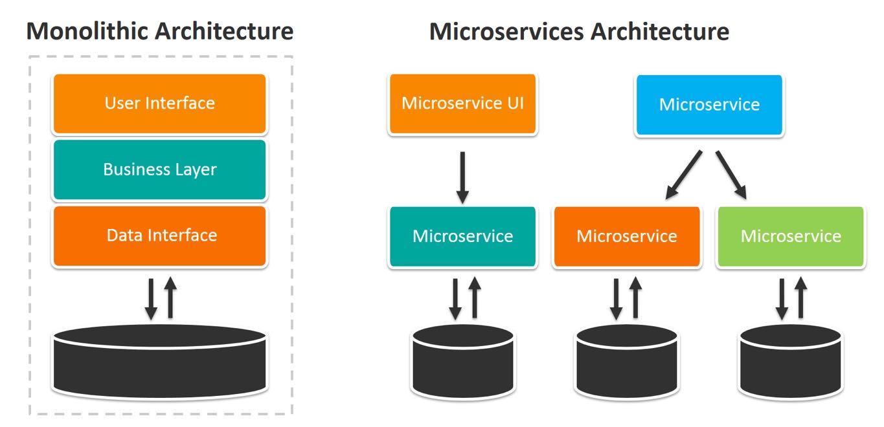

To create micro service architecture application using spring boot. Spring boot provided spring cloud modules. They provided us Server ie Eureka Server. Eureka Server is a type of registry or server which allow us to deploy more than one micro service projects. Eureka Server handle all configuration details about service, provide load balance feature, it check health of the application etc.

To implicit micro service architecture we need minimum two projects

1 Eureka Server

2. Eureka Client 1 8181

3. Eureka Client 2 8282

4. Eureka Client 3 8383

5. Eureka Client 4 8484

Eureka Server :

Web Starter

Eureka Starter

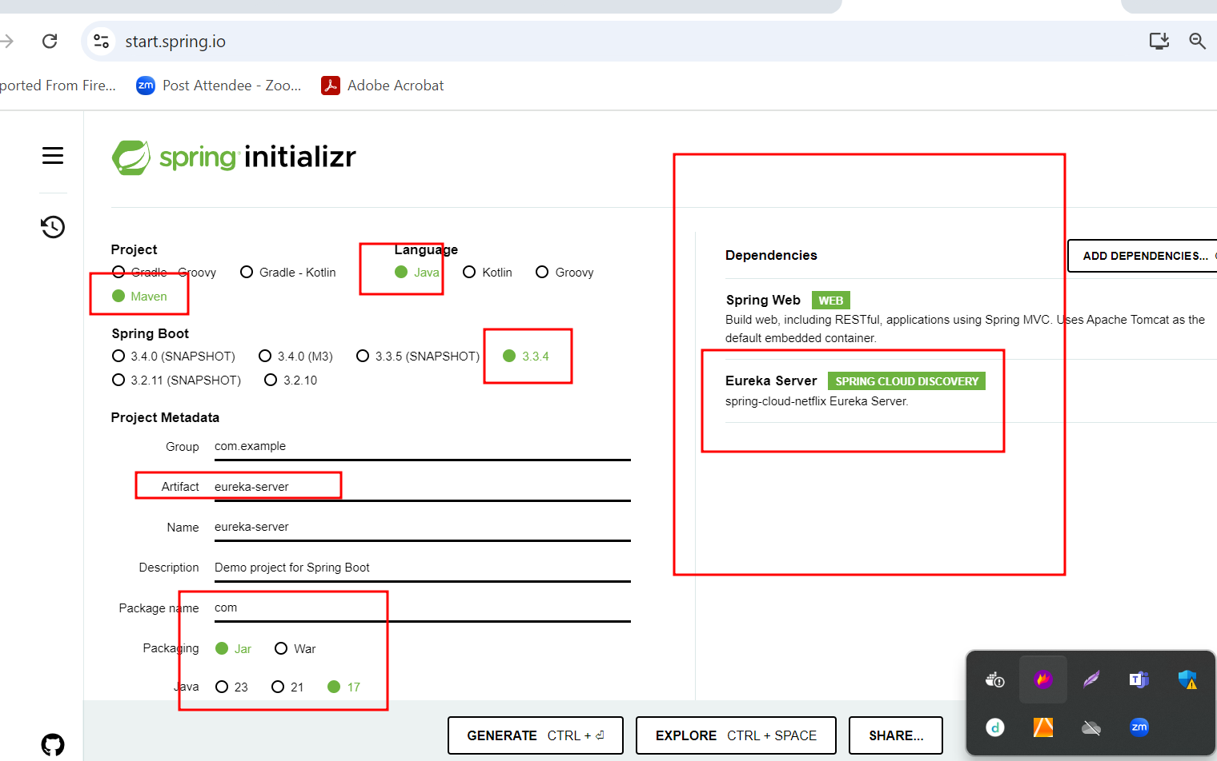

By default eureka server run on default port number 8761 port.

But we added web starter so eureka server run on port number 8080.

But in every micro service project we need mention eureka server port number. Because every micro service with eureka client application search eureka on port number 8761.

1. First-micro-service-app

Web starter -🡪 simple end point or rest api

Eureka Client -🡪 this starter help us to deploy project on eureka server.

